Kaneville United Methodist Church
Newsletter March 2023

When Our Hands Get into Trouble
By Rev. Nancy Blade
Do you remember the Sunday School song “O Be Careful, Little Eyes?” The verse about hands got me into trouble as a kid.
O be careful little hands what you do
O be careful little hands what you do
For the Father up above
Is looking down in love
So, be careful little hands what you do

I thought God wouldn’t mind if snuck a cookie from mom’s freshly baked cookie sheet. But I found out that it wasn’t just God that noticed. I was punished for reaching for food on the counter over my head, and yet that punishment wasn’t as severe as the lesson not learned. The next time I did the reach I put my hand on the hot electric coils of a stove. Owie! Those tears lasted for hours. But I got a lot of time with mommy along with it. That’s the love part. The mercy in the pain of sin.

Our Lenten Series will talk about the burden of human failure and how that relates to the mercy of the cross. Each week as we remember our frailty we look for the love of God to make it all right. We really need God when our suffering is strong, but do we know how to let God in?

There’s lots of Scripture on mercy. What is your favorite? “Blessed are the Merciful?” or “Surely goodness and mercy shall follow me all the days of my life?”
Let’s have a “mercy quotation” contest.
There’s a metal bucket on the Welcome Table to receive your found quotes – Scripture or positive thoughts. I will pick out of these to enliven our email conversations and bless our Tuesday Facebook scrollers.

The Worship Committee has decorated a display of hands at the front of the church to give us the unique perspective of where our hands have been. The first one crosses fingers behind themselves. The second is grabbing for relief. The third is thumbs down. The fourth has two hands in a relationship. And finally, the fifth volunteers themselves with one finger. These will be paired with our worship topics each week. I wonder if you can discern what we will be talking about.

Friends, I desire to make a place for you in these messages, so that you will find a place for God in your pain. It is only when we make room for God that God can do God’s best work – making the cross a place of healing. And tell your friends, there’s a place for them too.

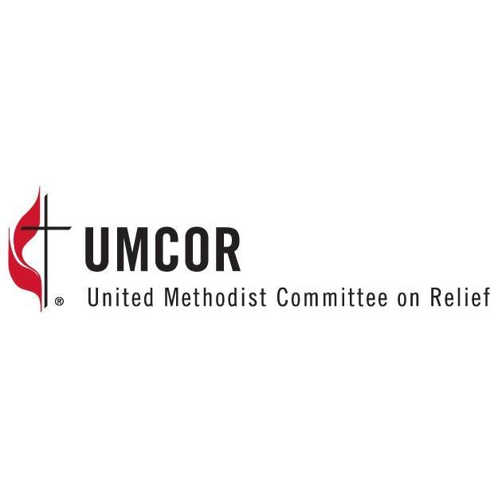
Missions
-Food pantry meal March 9, sign up sheet is on the welcome table.
-Our March Mission is UMCOR – The United Methodist Committee on Relief
UMCOR provides humanitarian relief and disaster response in the United States and internationally. These undesignated funds allow UMCOR to allocate funds to disasters as they arise.
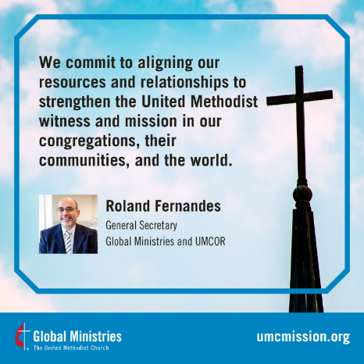
As the humanitarian relief and development arm of The United Methodist Church, the United Methodist Committee on Relief – UMCOR – assists United Methodists and churches to become involved globally in direct ministry to persons in need. UMCOR comes alongside those who suffer from natural or human-caused disasters – famine, hurricane, war, flood, fire or other events—to alleviate suffering and serve as a source of help and hope for the vulnerable. UMCOR provides relief, response and long-term recovery grants when events overwhelm a community’s ability to recover on their own. UMCOR also provides technical support and training for partners to address emerging and ongoing issues related to disaster relief, recovery, and long-term health and development.
UMCOR International latest responses
UMCOR and its partners are responding to disasters across the globe every day. Please join us in prayer for the affected areas and consider giving to UMCOR International Disaster Response to support these efforts.
UMCOR will provide further updates as they become available. For the most up to date information, follow the UMCOR Facebook page.
- Earthquake in Turkey & Syria
- Ukraine Response
- Migration & Refugees
UMCOR also responds to the latest US disasters.
Sources: Mission Links & https://umcmission.org/umcor/

The Anniversary Committee is looking to update our members' addresses to be able to send out invitations for our upcoming anniversary celebrations. If you have grown children that went to this church but don't presently attend, please provide us with those addresses. If you know of other former members or attendees that have moved away, and you have a current address, please let us know. You can email the secretary or leave a note in the pastor's box. We don't want to leave anyone out! We are also looking for any photographs depicting church events over the years or other relevant items. Photographs can be scanned & returned to you. Items can be on loan. Thanks!
Valentines
Thanks to all the kids, including our friends at KCCC, who made Valentines this year. Over 30 community members and college students received these special works of art. We also dropped off Valentine gift bags with candy, cards, and heart cookies to 10 of our church members who are in assisted living, the hospital or who are homebound. Special thanks to Alana for baking our cookies!

Peacemakers
We are so excited to be back at Peacemakers! All KUMC and community kids in kindergarten-5th grade are invited to join us Wednesday, March 15 from 6-7pm when we will be focusing on God’s amazing love for everyone and watching Horton Hears a Who. Games and treats too! Bring a friend or two! All are welcome!

Mother-Daughter Banquet Re-Boot!
SAVE THE DATE: May 7, 2023

Mark your calendars now for the 2023 KUMC Mother-Daughter Banquet: Vintage Vogue—A Century of Fabulous Fashion. All women in the community are invited to attend this very special 175th Anniversary celebration on Sunday, May 7 at 4pm. The evening will include the usual delicious potluck dinner, tributes, and awards and in honor of KUMC’s legacy of timeless beauty and glamour, a style show! So rummage through your attics for some classic clothes or horrible fads from the 1920s-today. We will need models of all ages and sizes! Anything too fragile (or tiny for a normal human to fit) can be carried or used for our display. Contact Carol Alfrey to help with the style show. Several leaders have stepped up to plan their work areas, but we could use some more. To get involved talk to Pastor Nancy who will put you in touch with the coordinators for the work area of your interest. Meanwhile, help us talk this up in your neighborhood and with current and former members. This is one of our 175th Anniversary Celebrations!

Check It Out!

No Wonder they Call Him the Savior
If you are looking for a thoughtful read this Lenten season, check out some of Max Lucado’s books in the KUMC library. In No Wonder They Call Him the Savior, Lucado guides his readers through the drama of the death and resurrection of Jesus Christ, bringing to life Peter's denial, Pilate's hesitancy, and John's loyalty.
In No Wonder They Call Him the Savior, Lucado portrays Jesus' final acts in a new light:
- His final prayer of forgiveness
- His plea honored
- His request of love
- His question of suffering
- His confession of humanity
- His call of deliverance
- The cry of completion
In No Wonder They Call Him the Savior, readers relive the events leading up to Jesus' crucifixion, from the foggy garden of Gethsemane to the incandescent room of the resurrection.
Lucado invites us to examine this hour in history by looking at the witnesses, listening to the voices, and observing the one they call the Savior. And, most of all, he challenges us to find hope in the unlikeliest place: at the cross.
I’m First
A Parent’s Prayer for Lent
“An argument started among the disciples as to which of them would be the greatest.” --Luke 9:46
Lord,
I know that sound of voices squabbling about who comes first. Oh, do I! First in, first out, first to open, first to take a turn, first to ride, first up front, first for seconds.
“I’m first…” is such an instinctive reflex, Lord. But You want to show my children a better way: “If anyone wants to be first, he must be the very last, and the servant of all” (Mark 9:35).
Teach my children, Lord, to be first to offer, first to step back, first to share, first to speak up for the quiet one, first to serve, first to say, “You first.”
Lord, when You taught Your disciples about who’s first in Your kingdom, You took a little child, put Your arms around him, and looked in his face. Then You said, “Whoever humbles himself like this child is the greatest in the kingdom of heaven” (Matthew 18:4).
This is my plea: When You come to our house today, may You find my children second in line—with the first place saved for You.
Amen.
(Taken from Praying the Bible for your Children by David & Heather Kopp)
History Corner
Early Church history in mid-1800s
Written by: Karen Flamand

The first permanent settler in Kaneville township was Amos Miner in 1836. His family settled out where Lone Grove forest preserve is now. The circuit riders preached at his home & others in the area. The Baptists were also holding services in Blackberry township & in 1841 the Rev. Ravlin organized a Baptist Church on the claim that would become the village of Kaneville. Over the years both denominations often did things together.
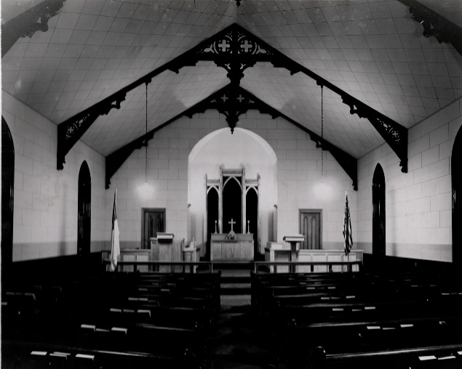
On August 20, 1844 the first Sunday School was organized on the John Bunker claim, but no special denomination was noted. Both congregations would meet on alternating Sundays at the new frame schoolhouse in Kaneville. This was located on the corner, empty lot next to Hill’s store.
On September 14, 1848, Henry Remington gave the deed for the lot where are church is now. This is the date used for our anniversary. In 1849, a little grout church was built. It had a balcony & the old white altar is from this first church.

Inside our church, November 1948

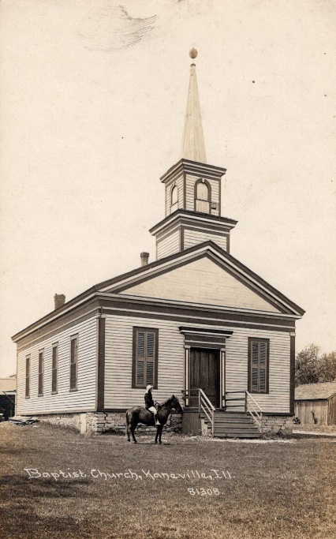
A brief history of the Baptist church: Organized in March of 1843 in Blackberry Center. On October 2, 1855, a new church was dedicated with Pastor Lathrup. It stood on the Dawn Hill apartments property approximately where the school bell is now. Soon after this dedication, the Fox River Baptist Association met here for their annual meeting. They discussed & voted on building a university on land donated by Senator Stephen Douglas. This would become the University of Chicago.
Eventually the little grout Methodist church became too small & was torn down & the present church was built in 1875. It was dedicated on November 7th; the church bell was presented at this time with an inscription. The total cost of the building was $5,634.36. In 2025, our church building will be 150 years old.
To see more history, check out the scrapbook done by Laurie Hannula in 2003. It has many pictures & other details. It’s by the elevator along with other displays.
The Baptist Church

Make this a Holy Lent
Worship at 9:30 am

Declare a holy fast, call a special meeting, get the leaders together,
Round up everyone in the country.
Get them into God’s Sanctuary for serious prayer to God. Joel 1:14 (the Message)
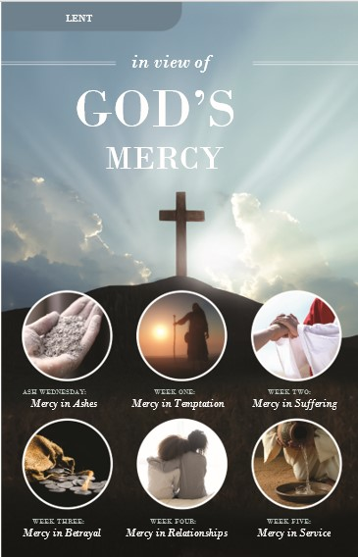
What this world needs is a holy revival. Who can bring this divine intervention? Only Jesus through the Word (preached and believed), through gospel focused music, and through intense prayer. Let us gather the people to meet God in person.

Notes about worship: As we make room for God this Lent we don’t give up our human nature, but we look deeper into our issues seeking the mercy of God, the place where God is reaching out to us.

Make a commitment to Sunday worship and to the fellowship of believers at KUMC this season. Let us not be afraid of what God can do with a repentant heart.

Join us for Holy Week in April
Palm Sunday Hallelujah Parade - April 2
Maundy Thursday Movie & Communion 7 pm
Good Friday Worship at Sugar Grove UMC 7 pm
Easter Sunrise Service – 7 am
Easter Breakfast – 8 am
Easter Resurrection Worship – 9:30 am

-Ladies, save the date!
We’ve been invited to attend the United Methodist Women’s Cluster Luncheon. This year it is at Geneva UMC. The event is on Saturday March 11 from 11:30-2pm. The speaker will be from World Relief. Please bring the following to share: Bread/Rolls. World Relief is in need of donations for refugee families. If you are able, please consider donating, list can be found on printed invite on welcome table. RSVP the number attending from your church by Sunday, March 4 to Marilyn Heinemann, Preston52@comcast.net or 630-762-9936
Additional this year! Bring your children to come take part in our Spirited Kids Adventures for ages 4-11. Register using QR code found on invite printed on welcome table. Childcare for younger children available upon request.
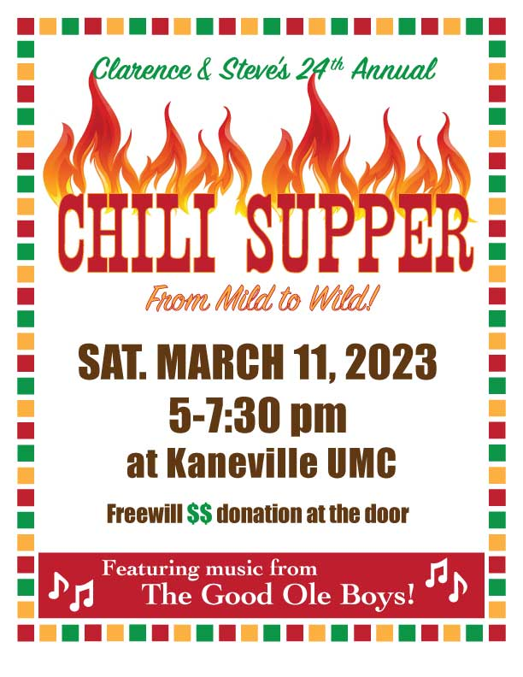
Be in the Know as a United Methodist

Check out the latest UMC news in the online copy of the Reporter newspaper at https://www.umcnic.org/media/files/Reporter/2023-03_Reporter_web_version.pdf
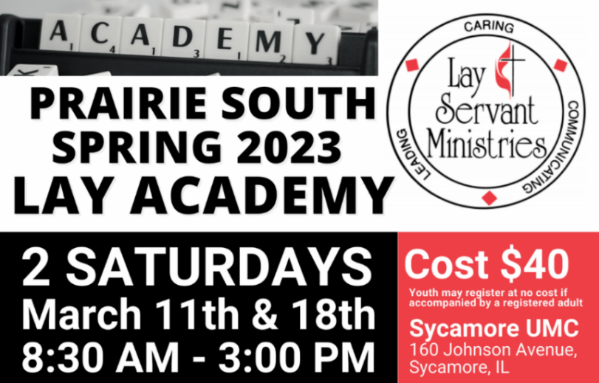

MARCH BIRTHDAYS
March 5 Sean Flamand
March 6 Diane Pierson
March 8 Robert Farley
March 9 Sharon Werrline
March 13 Don Angell, Karl Kettelkamp, Micayla Bartholet
March 14 Eva Ottoson
March 17 Elizabeth Ladford, Carly Schoonover
March 18 Brittany Bartholet
March 19 Karon Miller
March 22 Erica Plumb
March 24 Melissa Fox
March 25 Lisa Vanatta
March 26 Ben Flanders
March 28 Carol Flanders
March 29 Lynette Werdin, Brynley Schrader
March 31 Karen Flamand
MARCH ANNIVERSARIES
March 30 Eric & Chris Baldridge

 |  |  | 1  Praise Band 6:30PM  Choir  7:30PM | 2  Food Pantry Service  5:30pm | 3 | 4  Men's prayer Group 7AM  Grace Church
5  Worship  9:30AM  Kidzone  No women’s class | 6  KCCC  Board Meeting  7pm | 7 | 8  Praise Band 6:30PM  Choir  7:30PM | 9  Food pantry meal | 10 | 11  Men's prayer Group 7AM  Women’s UMC lunch  11:30am  Chili Supper  5pm
12  Worship 9:30AM  Kidzone 10am  Adult classes  10:45am | 13 | 14 | 15  Peacemakers 6pm  Praise Band 6:30PM  Choir  7:30PM | 16  Admin Council Meeting  (in person)  7pm | 17  St. Patrick’s Day | 18  Men's prayer Group 7AM
19  Worship 9:30AM  Kidzone 10am  Adult classes  10:45am | 20  First day of Spring! | 21  Card Ministry  9:30am | 22  Praise Band 6:30PM  Choir  7:30PM | 23 | 24 | 25  Men's Prayer Group 7AM
26  Worship 9:30AM  Kidzone 10am  Adult classes  10:45am | 27 | 28 | 29  Praise Band 6:30PM  Choir  7:30PM | 30 | 31 | 1  Men's Prayer Group 7AM
MARCH 2023

